Lambgates Patient Participation Group
Venue: Lambgates Health Centre, Lower Ground Floor Meeting Room
Tuesday 4th July 2023
14:00-15:00pm
Attendees: XXXXXXXXXXXXXXXXXXXXXXXXXXXXXXXXXXXXXXXXXXXXXXXXXXXXXXXXXXXXXXXXXXXXXXXXXXXXXXXXXXXXXX
Apologies: XXXXXXXXXXXXXXXXXXXXXX

Agenda Items:
- Glossop Arts Project – Clare Isherwood
Clare Isherwood from Glossop Arts project attended the first half of the PPG meeting to inform the group about the activities and sessions that run throughout term time for the residents of Hadfield and Glossop. Glossop Arts project is in its 10th year providing art for the wellbeing of a range of people in the local community with a special focus on supporting those with long term mental and physical conditions.

Glossop arts project relies on charitable donations and funding from companies such as the big lottery. The last 3 years have been funded by Children in Need, but the current funding request for the next 3 years has been rejected with their reasoning being they are providing activities that statutory services should be providing. SS will, if the opportunity arises, will bid for funding from our landlords to support this group.
Glossop Arts project is made up of 6 volunteers who all work part time throughout term time. Glossop Arts Project is based at Victoria Hall (The old Library) in Glossop where they deliver a creative safe space with counsellors present at each session. All the staff are mental health first aid trained and are keen to support the children and adults of our community with their wellbeing. The team have a variety of different groups each with their own focus, referrals can be made through the GP, the bureau or via self-referral on their website. Some examples of the groups running are listed below.
- Wednesday 10am-12pm Learning Disability Group – Victoria Hall
- Thursday 10:30-12:30 The Place @ Glossopdale School
Tea, coffee, and refreshments are provided at the sessions- more information on the services they provide and the sessions they offer are available on their website: https://glossopartsproject.org/
We hope to have a member of the Glossop Arts Project present at our Macmillan Coffee Morning/ Flu Vaccination clinic alongside the PPG in September/October time to promote these sessions further, which will allow an opportunity for patients to engage and ask questions.

- PCN Update
Adverts have recently been published for the following roles to join our Glossop PCN team.
- PCN Pharmacist
- PCN Counsellor
- PCN Respiratory nurse
ET/SS very much look forward to having these additional roles available for the patients of Glossop and Hadfield to access.
- Surgery Update
One of our long-standing members of the reception team, Felicity, has recently retired on the 30^{th of} June 2023. We wish her all the best and would like to thank her for all her hard work and commitment to Lambgates over the last 10 years. These vacant hours will be replaced with a Full time Apprentice receptionist who we very much look forward to joining the Lambgates team in early August.

Our reception/officer manager, Kate, who has worked at Lambgates for the last 10 years has taken on a new position as Lambgates GPA (General Practice Assistant), this is a role within the Glossop PCN. Patients may be contacted by Kate when she is liaising and working alongside the GP, this is a new and exciting role to General practice, and we are very proud of Kate for taking on this new challenge. A GP assistant will have a mix of both basic clinical and administrative skills to support and take some of the lower-level workload from the GPs in order for them to spend more time on the higher demands of patient care.
- Complaint -Surrounding Website Accessibility
A complaint was received by the practice in June 2023 which included concerns about the accessibility of the website, comments were raised suggesting that our practice website was not fit for purpose. ET/SS on behalf of the practice, would kindly like to ask for the PPG members feedback on these comments and would appreciate if you could take some time to review our practice website to see, from a patient perspective, if there are any improvements you think could be made to make the journey for patients wanting to find out information from us a smoother process. We look forward to returning to this agenda item at our next meeting where we can discuss suggestions further. In addition to the complaint a new national package has brought in as a new focus for General practice this year known as the Capacity and Access direct enhanced service which also focuses on patients’ feedback and views of primary care. One of which is the national patient survey results https://www.gp-patient.co.uk/patientexperiences?practicecode=C81106 which asks patients about their views on the practice website (Q4, How easy is it to use your GP practice website to look for information or access services) – your input with this would be greatly appreciated.
- Extended Access Update – Based at Howard Street
ET briefly refreshed the PPG members on what the Extended Access service was and who it was available to. Uptake is slowly increasing, and the service is getting some really positive feedback. 39 of Junes 40 responses said they were extremely likely to recommend the service to their friends and family.

ET asked the members if they could assist in promoting this service to encourage the utilisation of the evening and weekend appointments available. The funding currently offered to the Glossop area to deliver this service is given with the utilisation target of 80%, which proves that the service and additional access is required. Currently in Glossop we are only just hitting around 70% with some months even lower, because of this the local ICB (Derby & Derbyshire Integrated care board) have put the Glossop Extended Access provision under a 2-month review, which could mean that if utilisation does not increase in this time the funding is revoked and the service will be no longer available.

Steps we as a PCN have taken to prevent this from happening include a push from the receptionist at each of the 5 practices to offer these appointments more on the phonelines. The EA team have slightly amended the appointment book which previously allocated slots to the practices based on their patient list size to now being open for all to encourage the booking of the appointments for all practices without the restrictions of slots and times specific to them. Posts have circulated the practices social medic pages along with the local Glossop health team page. ET/SS asked the PPG members to spread the word and encourage their friends and families to take up the offer of these appointments when they are given.
- NHS 75th Birthday Park Run – 8th & 9th July 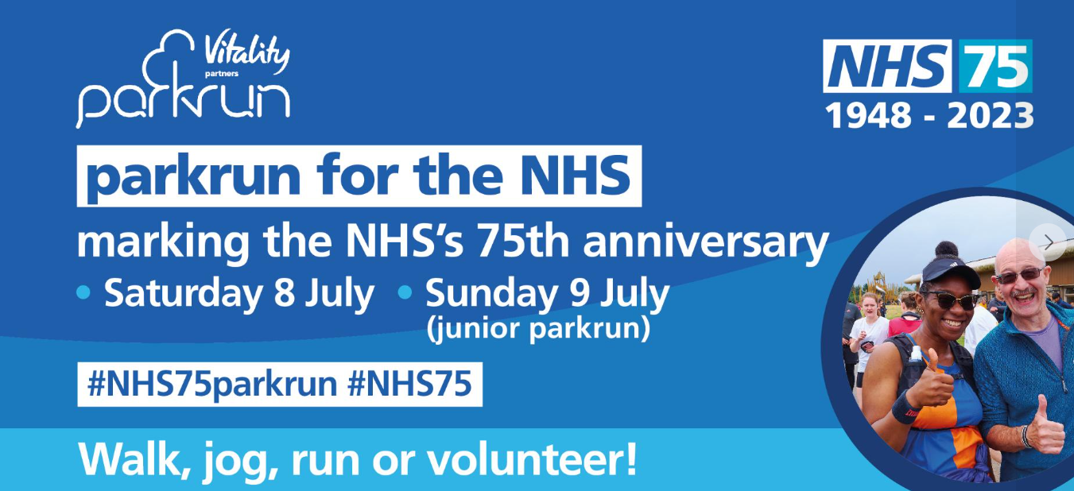
Please feel free to attend with friends, family, colleagues- run, walk, jog, or simply cheer!

- GNPG – Glossop Neighborhood Patient Group meeting 09th May
CG and PPG member attended. One of the main points brought back from this meeting was following a large discussion that took place around long-term conditions and the importance of the awareness of managing these. The attendees were urged to attend an online course in relation to long-term condition management. After discussing the importance of why patients should attend for their annual reviews and the importance of patients taking responsibility for their own health care with the other PPG members CG is going to take part and enroll for the course and feedback following completion. We as a group are hopeful that an insight into the importance of LTC’s further will help us promote the PPG and support other patients to attend groups such as the Glossop Arts project.
- Lung Health Check Invite Error
‘We have been made aware of an error with the data that has been used to invite patients for a Lung health check, meaning that you may have been invited for this even though you may not be eligible. If you're aged between 55 and 74 and have ever smoked, you are eligible and are advised to arrange an appointment. If you are not in the category above and have been invited, please disregard the invite. We have contacted the team and reported this issue with them, who have assured us that they are solving this error. We appologise for any inconvenience this may have caused.’
- How can we promote our PPG?
At our last meeting we discussed sending a text to all patients to encourage participation. Unfortunately, there is no financial budget to cover the SMS fee for sending an SMS to 7,000 patients. There have been claw backs to our freedom to the amount of SMS messages we can send but if this changes in the near future ET/SS are happy to do this.

CG suggested that putting a focus to the meetings may encourage uptake to a specific cohort of patients such as ‘Working Mums’. The PPG meetings would have to consider the needs of the focus groups, for example working mums may need a later meeting to attend but this is defiantly something we can look at doing. How can we advertise a focus meeting? For further discussion.
We also discussed just how updating our PPG notice board and putting a focus on here may encourage patients to join as this can be noticed whilst patients wait for appointments. EB, AB, and SG are all keen to get this updated and we are hopeful that this will have more up to date and current information on in time for the Macmillan /Flu and PPG Promotion morning in the winter.
The Macmillan coffee morning this year is scheduled for September 30th. We suggested that we try to plan our seasonal flu clinic around this so that the PPG can promote themselves and take this opportunity to gain new members and hand out leaflets explaining what the PPG is and how it can make a difference. SS/ET will wait until the flu vaccination orders have been confirmed and then will confirm dates with the group. ET has looked at any existing leaflets we have but they are now very out of date with old information in so it would be great if this is something that can be created between the members in preparation for the coffee morning. AB has kindly offered, with the help of her husband and his graphic designing skills, to look at compiling a new poster/leaflet. This can be shared in the local shops, reception notice board and clinical rooms once done. We even discussed cooperating CG idea of adding a focus to the leaflet to give people a space to suggest ideas.
Going forward as we start to engage more and increase our PPG ET suggested to the team that it would be nice to allocate a chair and a secretary from the PPG board to help coordinate these meetings and events. AB suggested this could be taken in turns. For further discussion.

- Then the next PPG meeting will be held at Lambgates Health Centre, Lower Ground Floor Meeting room on Tuesday 5th September 2023 at 2:00pm. Please sign in at reception when you arrive. We look forward to seeing you then

