Lambgates Patient Participation Group
Venue: Lambgates Health Centre, Lower Ground Floor Meeting Room
Tuesday 5th September
14:00-15:00pm
Attendees: XXXXXXXXXXXXXXXXXXXXXXXXXXXXXXXXXXXXXXXXXXXXXXXXXXXXXXXXXXXXXXXX
Apologies: XXXXXXXXXXXXXXXXXXXXX

Agenda Items:

1.PCN Update
We have advertised for a further two paramedics to join Ben in the PCN. The last interview was this afternoon and has been successful so far. The two paramedics appointed will join Ben completing home visits for the 5 practices of Glossop and Hadfield alongside the delivery of acute clinics based on one of the practices.

2. Practice Update
One of our long-standing members of the Clinical Team, Margaret Booth, is retiring on the 30^{th of} October. We wish her all the best and would like to thank her for all her hard work and commitment to Lambgates over the last 7 years. These vacant hours will be replaced with a Full-time practice paramedic who we very much look forward to joining the Lambgates team in early November. This vacancy has been filled by Scarlett Kershaw, a previous member of Glossop PCN.

We have recently appointed an apprentice medical receptionist – Gian Luca Samaracco. He has completed just 1 month at lambastes and is settling in really well. Gian Is completing a 12–15-month level 2 customer service apprenticeship.

One of our existing salaried GP’, Dr Charlotte Trail is in the final stages of being signed off for her minor surgery contraceptive procedures and will then be delivering a monthly session on a Monday for the patients of Glossop and Hadfield of Lambgates and surrounding practices by referral from their GP. I’m sure we can all agree this is a great local service to have access to prevent patients from having to trave l to the orange rooms and secondary care providers.
Autumn/ Winter Vaccination program
Covid Phase 7 – Glossop PCN will deliver in the same model as previous years. The week commencing 11th Sept will be the start of Care home and housebound vaccinations. The week commencing 18th will be the first of the clinics based at Simmondley medical Centre.

Flu Vaccinations will be delivered by practices individually. Clinics have been planned for all practices In Glossop. Lambgates Clinics – 16th and 23rd September

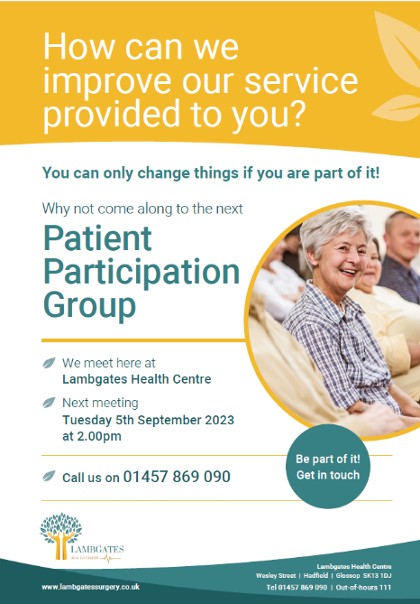
Appointments will be bookable in the same way as previously via 119 or the booking link. Clinic dates and links will be shared on the practice’s social media pages as well as the Glossop Health Team.

3. PPG Poster
One of our Members, Ann, has kindly created a NEW PPG poster to help us promote our group. This has been shared on our social media and in the waiting room. Thank you, Ann.

4. Macmillan coffee morning
Discussions took place with the group if it was of interest to support the practice with the coffee morning stall in collaboration with one of our flu vaccination clinics. We have done this once previously and it worked really well. We could take this opportunity to promote the PPG and hand out some of our new posters with the next date on to encourage participation. AB was keen to support this and is available on the 16^{th of} Sept. CR was equally happy to support the delivery of this and is available on the 16th also. AB and CR have agreed to meet at Lambgates at 9am to run the stall. ET will contact both MH and SG to see if they are interested and wish to join them. ET will share this with the staff who will hopefully help bake for the stall.

5. Personalised Care Leadership Course – GNPG – Feedback from CG
CG shared his feedback with the group on the course suggested after discussions at the Glossop neighborhood patient group. CG advised that this course starts free and then is either available to buy for £99.00 or by subscription for £20.00 every 2 months. CG had some concerns regarding what the course entailed. He explained to the group that the course doesn’t explicitly state which long-term conditions it relates to. CG has compared this offer with the support he has received personally from LLBD and services via GP referral at George Street. The benefit of LLBD and George Street is that they provide weekly sessions face to face at the leisure Centre, they deliver sessions via video and there is also printed material available- free of charge. Whereas the GNPG course suggested has one mean of delivery via computer and is not specific to certain long-term conditions and has a cost. CG concluded that there is not really any measurable benefit of this course and will feed this back to Lesley Surman and the rest of the GNPG board but will emphasize that this is subjective.

AB and CR were not aware of some of these services that CG had mentioned that were available via GP referral.

ET/SS added to this and explained that one of our current GPST3 junior GP’s Dr Thornton is just in the final stages of completing a Care Navigation booklet as part of her leadership project for patients that can be available at reception to advise patients of the different services and allied health care professionals are available to them when requiring health related support. ET /SS will hope to have some of these printed for the flu vaccination clinic also as there is a large footfall of patients at these clinics.

6. National Patient Survey Results – July 2023
ET talked through Lambgates most recent results. A total of 338 surveys were sent out, Lambgates received a total of 121 surveys completed with a completion rate of 36%. Overall, the practices were rated 87% which in comparison with the national average of 71% and the ICB average of 72% is great. Overall, in all areas the practices and the Glossop PCN are in line if not above the national and ICB average in all areas. One of the areas we asked the PPG members to help us with for a complaint at the last meeting was around our website accessibility. This falls into one of the questions within the national patient survey also. AB has done this for us and thinks our website is one of the best she has seen. She commented on some of the wording used ‘Other rooms’ suggesting other services which she suggested could be confusing for some patients – ET/ SS agreed and would look into whether this could be altered. CR is happy to review the website for us on both a computer and a phone and feedback at the next meeting.

7. The next PPG meeting will be held at Lambgates Health Centre, Lower Ground meeting room on Tuesday 5th December 2023 14:00-15:00pm. Please sign in at reception when you arrive. We look forward to seeing you.

