

Lambgates Patient Participation Group
Venue: Lambgates Health Centre, Lower Ground Floor Meeting Room
Tuesday 18th February 2025 - 14:00-15:00pm
Attendees:
Katie H | Ann B | Elsie B | Maureen H | Chris G
Apologies:
Kathie (virtual member)

Minutes

Practice Update

Staff

We’re pleased to share some positive news with our patients. From October, Dr Trail will be joining Dr Ahmed and Dr Gilliland as a Partner at the practice. Dr Trail is a fantastic addition to our management team, and we’re confident that her experience and commitment to patient care will further strengthen the services we provide.

Claire, a member of our administrative team, has recently completed phlebotomy training. She will continue to be part of our reception team while also occasionally assisting the nursing team. This forms part of our resilience planning to ensure we can continue to offer a high level of care and flexibility within the practice.

We are currently advertising for an apprentice to support the administrative team and help cover some of Claire’s hours. The practice is committed to developing new talent and has had great success with previous apprentices, many of whom have gone on to secure permanent roles within the team.

Some of our team members have signed up for the Big Step Challenge, which kicked off on 16th May. We're walking with purpose — aiming to cover the full distance of England’s World Heritage Trail. That’s an impressive 1,558 km (968 miles), or a staggering 2,271,460 steps! We’re taking part because we believe in the power of movement — to boost wellbeing, support healthier lifestyles, and reconnect with the rich history that surrounds us. Teams from other practices across Tameside and Glossop are also getting involved, sparking some friendly competition and encouraging us all to keep stepping! We'll be sharing our progress along the way, but why not let this inspire you to lace up your shoes and get some steps in too?

Merger update

- We are still very much in the early planning and collaboration stages of the merger. Currently, we are in the draft phase of completing the necessary legal agreements, which will mark the beginning of our transition journey.
- We want to reassure patients that there will be no site closures or redundancies as a result of the merger. The aim is to strengthen our services and improve resilience by working together.
- Regular virtual meetings have commenced between our management team and the team at Cottage Lane Practice, taking place on a weekly basis.
- At this stage, there is a significant amount of back-office work to complete before patients will begin to notice any visible changes.

- We have shared an initial announcement on our website, Facebook page, and via a banner displayed in the reception area.
- A dedicated email address has also been created for patients to submit questions or concerns. ddicb.mergerqueries@nhs.net
- We are committed to keeping the PPG informed and will provide further updates as the process progresses

Website Updates
We have recently updated our practice website to include more accessible and useful information for patients and carers.

New resources have been added under the following topics: Autism, Learning Disability, Elderly Care, Abuse and Mental Health. These sections are designed to offer support, signposting, and helpful links for patients, families, and carers navigating these areas of care.

We have also updated our Policies Index, which includes a new section titled ‘Common Requests We Cannot Accommodate’. This section is intended to help manage expectations around requests that fall outside of NHS GP responsibilities. It provides clarity for patients and helps reduce misunderstandings or delays.

We encourage members of the PPG to take a look and welcome any feedback on how we can continue to improve the website for all users.

Pharmacy Review Clinics
Clinical Interface Services have been supporting our practice by providing pharmacist-led reviews for patients with established cardiovascular disease (CVD) or those at high risk. Over the past few weeks, they have been running diabetic review clinics and will soon begin COPD reviews. This additional support has brought significant benefits to both the practice and our patients.

Research
We are pleased to share that the practice has recently signed up to become a research practice
This means we are now part of a network of GP surgeries across the country that support NHS-approved clinical research. As a research practice, we may be invited to take part in ethically approved studies that aim to improve patient care, develop new treatments, or better understand health conditions.

We have already submitted a number of Expressions of Interest in relevant studies. This simply means we’ve indicated our willingness to receive more information and consider participating, depending on the nature of each study and whether it is suitable for our patient population.

Participation in any research is voluntary for patients. You would only be contacted if a study is relevant to your health, and full information and consent would be required before taking part.

Patient Experience

Friends and Family

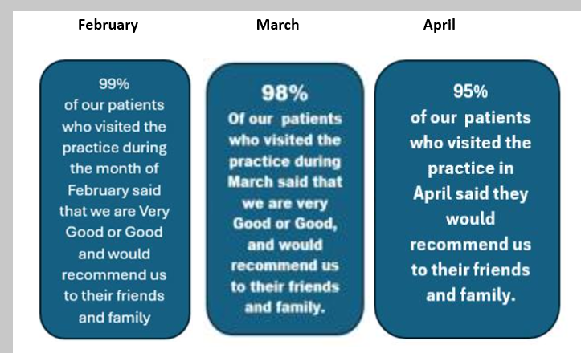
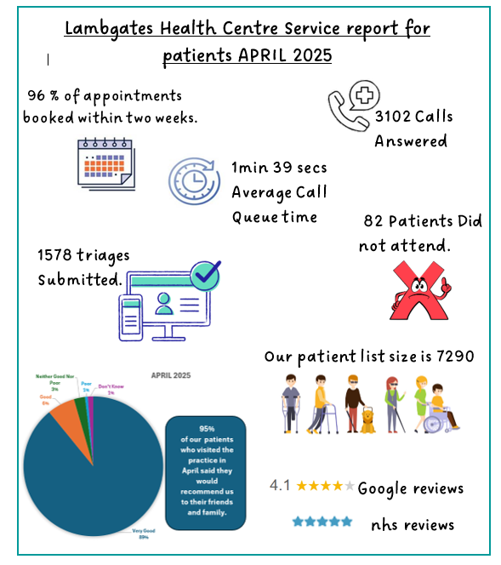
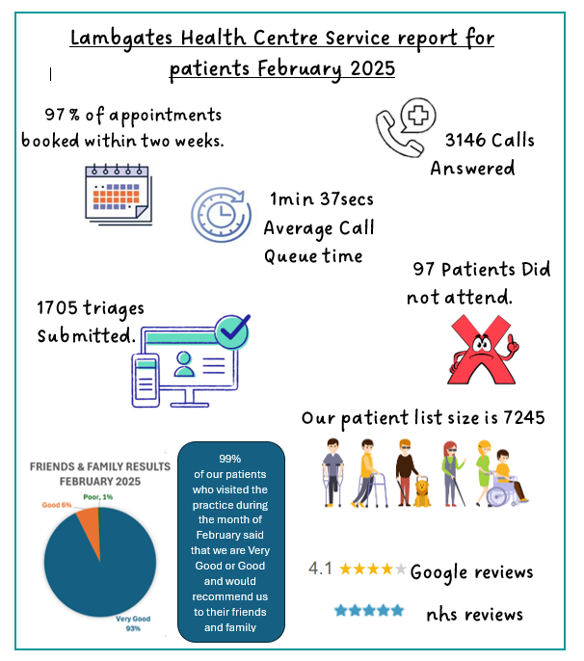
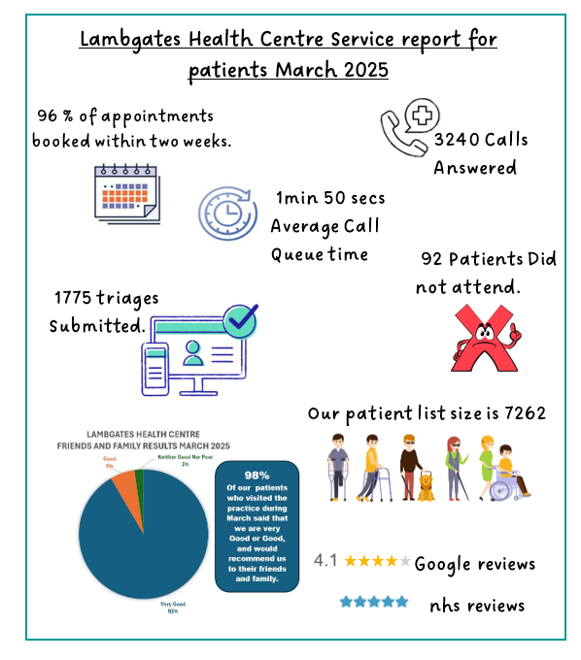
Complaints
As part of our commitment to transparency and learning, we continue to review and reflect on all complaints received.
We appreciate feedback from patients as it allows us to identify areas for improvement and provide training where needed to enhance patient experience.

February. 1 Complaint
- Medical Records not transferred from previous practice
March. 2 complaints
- Delayed prescription.
- MSK Wait times
April – 2 complaints
- Triage closed for Target
- Dental issues not correctly signposted.

Key learnings
One complaint related to a dental issue that was not correctly signposted by a trainee GP. The patient was initially directed to the GP service rather than being advised to contact an appropriate dental provider. This case provided valuable learning for both the trainee GP and the admin team. The trainee GP has received additional guidance on appropriate signposting for dental concerns, which fall outside the scope of general medical services.
The admin team has also revisited key protocols for handling dental-related queries at reception and over the phone, ensuring patients are triaged or directed to the correct services from the outset.

PCN Update
We are pleased to welcome two new members to our Primary Care Network (PCN) team:
- Jordan, who has joined as the new PCN Business Manager, and
- Christy, our new PCN Paramedic.
Jordan will be supporting the PCN with strategic planning, coordination of services, and helping to drive forward collaborative initiatives across member practices.
Christy will be joining Paramedic Rich working across the practices to provide clinical support, help with urgent care, and improve access for patients with acute needs.

PPG Recruitment / Involvement
In an effort to improve engagement and attendance, we are now offering virtual invitations to Patient Participation Group meetings. This allows patients to join remotely and take part in discussions without needing to attend in person.
We’ve had a positive response so far, including feedback from one of our virtual members who thanked us for introducing this option. Although she is currently away on holiday, she expressed interest in joining a future meeting.
We would also like to thank our existing PPG members who regularly attend and contribute their time, feedback, and ideas. Your involvement is greatly valued and helps us to improve the care and services we provide.
We hope that offering virtual attendance will encourage greater involvement from a wider range of patients and make the group more accessible to all.

Thank you also to our Patient Participation Group (PPG) for updating our Community Notice Board in the waiting room. The “Did You Know?” section is a fantastic addition, sharing helpful information about local groups and services available in our area. It’s a great way to keep our patients informed and connected to the wider community.

AOB
The next Macmillan Coffee Morning will be held on Thursday, 26th September. The PPG has always done a fantastic job organising and running this event, and we’re pleased that they’re happy to do so again this year. The practice has agreed to purchase a catering urn to support the event. In addition, the PPG has expressed an interest in supporting local charities. To help decide which causes to support, we will run a poll on our social media channels to gather suggestions from the community.
The PPG has made some helpful suggestions regarding the layout of the waiting room. One of the key ideas is to reposition the television to a more prominent location. This would allow the practice to share important news and information more effectively via the on-screen banner, ensuring it is visible to a larger number of patients.

Our Next PPG Meeting
Our next Patient Participation Group (PPG) meeting will take place on Tuesday, 12th August at 5:00 PM.
We are trying a later time to see if it’s more convenient for attendees and to help encourage new members to join.

