

Lambgates Patient Participation Group
Venue: Lambgates Health Centre, Lower Ground Floor Meeting Room
Tuesday 12th August 2025 – 17:00
Attendees:
Anne | Chris R | Chris H | Eleanor | Debbie
Apologies:
Elsie | Chris G | Katie | Maureen

Minutes

Welcome
This month we were delighted to welcome our newest PPG member, Chris H! It’s always great to see new faces, and we’re working to make sure our PPG reflects the full diversity of our practice community.

As members, you play a key role in helping us grow the group. If you know any other Lambgates patients who might be interested, please do encourage them to get involved – and even better, bring them along to a meeting!

You can find more information about the purpose and benefits of joining a PPG on our practice website:
patient participation group
Here you will also find our meeting guidelines, which include:
- The PPG is not a forum for personal complaints or individual issues.
- Patient confidentiality is vital.
- All members should be treated fairly, equally, and with respect.
Together, we can make the PPG a welcoming, representative, and positive space for everyone.

Practice Update

Staff – Admin
This month we’re excited to welcome two new friendly faces to our admin team! They join us following Kelly’s departure to pursue a clinical role elsewhere, as well as to cover some hours made available by changes to working patterns.
Please say hello to Clare P, who is joining us part-time, and Olga, who will be working full-time. You may see them at the front desk or speak to them on the phone.

We were fortunate to receive a huge number of applications for these roles, but we feel Clare and Olga are the perfect fit for our practice – bringing the professionalism and high standards we’re so proud of.

Staff – Clinical
6th August marks GP trainee changeover week in Primary Care, which means we have the pleasure of welcoming four new members to our clinical team: Dr Akhtar, Dr Lawal, Dr Coe, and Dr Vyas. We’re excited to have them on board and look forward to the fresh ideas, energy, and skills they’ll bring to the practice.

Supporting and mentoring the next generation of doctors is a key part of who we are. If you missed the news on our Facebook page, we’re proud to share that we’ve recently received Silver and Gold Awards from the University of Manchester.

These awards recognise our outstanding dedication to helping future doctors on their journey to becoming General Practitioners and celebrate our ongoing commitment to nurturing talent and guiding careers in primary care.

PCN Update
Glossop Primary Care Network are currently recruiting and developing a team of Clinicians to form a “Team Up” hub.
A Community Matron, Christine is first to join with GP recruitment currently underway. Team Up, which already operates across Derby and Derbyshire neighbourhoods, provides reactive and proactive care to people unable to leave their homes. It incorporates at-scale Home Visiting Services, Rapid Response nursing, therapy and social care, falls prevention and response, and enhanced health in Care Homes.

GPs and other professionals will be able to refer patients to Team Up if they believe the patient would benefit from on-going monitoring or additional time especially if they are identified as having high needs.

We will update you as new information becomes available.

Merger News
We want to reassure patients that the merger between Lambgates and Cottage Lane is expected to have a minimal impact on them. Work on merging the administrative and "back-office" functions of our practices is currently underway.

Since our last PPG meeting, Cottage Lane manager Kathryn, has resigned to pursue a promotion opportunity elsewhere. This decision was not connected to the merger, and we wish her all the best in her new role. The management team has decided not to replace Kat. Instead, Eleanor and Debbie will manage both practices, dividing their time between the two sites throughout the wee

To reiterate our earlier discussions, while there will be changes in management and premises in the future, this merger is intended as a 'merging of best practices' designed to benefit all our patients. We are bringing together the strengths of both practices, rather than having the larger practice simply absorb the smaller one
Patient Experience

We share our service reports with PPG members and patients to give everyone a transparent view of how our practice is performing – from patient access to appointment availability and other key measures. It helps keep our community informed and gives members the opportunity to offer ideas or feedback that can help us improve.

We also share a summary of any complaints and significant events we encounter, not to focus on the negatives, but to show that we take concerns seriously and use them as opportunities to learn. By reflecting on what happened, identifying what could have been done differently, and making changes where needed, we aim to continually improve the care and service we provide to all our patients.

Service Reports
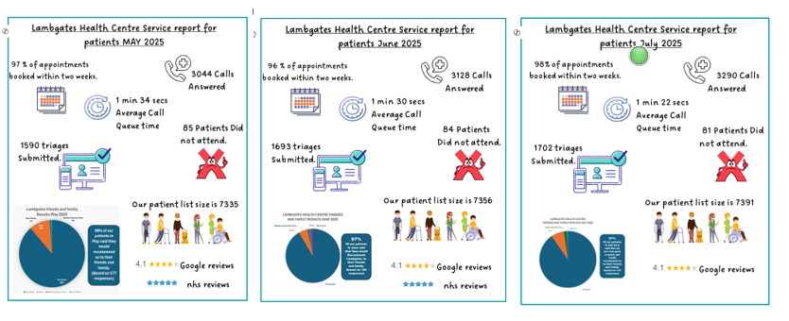
We anticipate a slight decrease in our Friends and Family Test results for August. This is due to Junior Doctor strikes and recent GP changes, which have meant appointments have not been as readily available as they normally are.
However, we want to assure you that our availability has remained well within NHS guidelines and our Triage GPs continue to prioritise appointments based on urgent need, ensuring that all emergency patients are seen.

Complaints
Below is a summary of the complaints we received during May, June, and July.
Month | No. of Complaints | Summary of Dissatisfaction | Learning / Changes
May | 0 | – | –
June | 1 | Concern over treatment plan for health condition. | Withdrawn at patient’s request; recorded as feedback.
July | 2 | 1) Dissatisfaction with referral process.2) Missed blood test & confusion over Child Immunisation recall. | 1) Resolved via phone; no change needed.2) Our error; Child Immunisation recall process reviewed.

Digital Health Support
Emma Delaney, the Digital Health Lead at The Bureau, spoke to us at our practice meeting this month about how empowering patients to use the NHS Digital Health app can be beneficial for them and for the practice
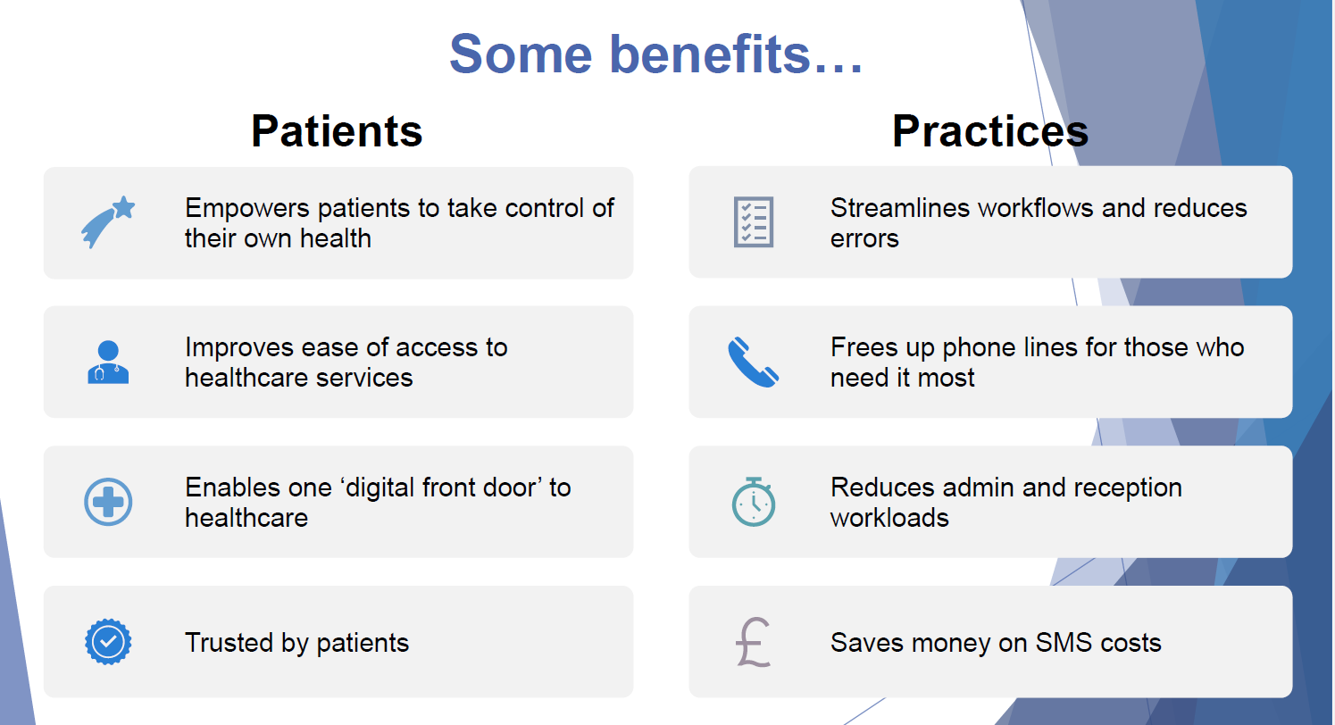

The Digital Healthcare Support Services Team is offering a series of workshops in the coming months to teach Glossop residents how to use NHS health apps. We're looking for our PPG members to help us spread the word. You might even want to attend one of the workshops yourself!

Here’s the schedule for our upcoming events:
Sat 13 Sept (mid-late morning) – Bradbury House
Mon 13 Oct (late afternoon/evening) – Bradbury House
Wed 5 Nov (late morning) – Hadfield Methodist Church
Mon 24 Nov (late morning) – Bradbury House

Macmillan Coffee Morning

We are excited to announce our upcoming Macmillan Coffee Morning on Friday, September 26th, starting at 9:30 am.
To make this event a continued success, we're looking for enthusiastic volunteers! We would be so grateful for your help with either:
- Running the event: Serving coffee and tea, assisting with the raffle, or setting up and tidying up.
- Baking cakes: Contributing some delicious homemade cakes or bakes for us to sell.

If you are able to lend a hand, please let us know! All money raised will go directly to Macmillan Cancer Support. Thank you for helping us support this incredible cause!

Our Next PPG Meeting
Our next Patient Participation Group (PPG) meeting will take place on Tuesday 18th November at 2pm.
We will be inviting members of Cottage Lane PPG to join us and hope to have guest appearances from some of our partner GPs.

